**Azure-data-factory-integration**

This project implements a comprehensive enterprise data integration platform leveraging **Azure Data Factory (ADF)** as the orchestration engine and **Snowflake** as the primary data warehouse. The solution provides a scalable, reliable, and maintainable framework for ingesting, transforming, and loading data from multiple source systems including Azure SQL Database, Blob Storage, Cosmos DB, and REST APIs into Snowflake.

The platform enables both batch and incremental data processing with robust error handling, monitoring, and data quality checks, serving as the foundation for the organization's analytics and business intelligence capabilities.

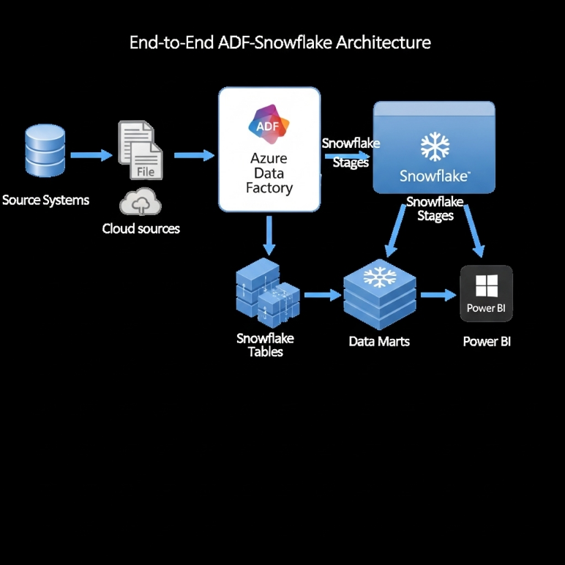

**2. Objectives**

The primary objectives of this Azure Data Factory integration project are:

* **To Establish Unified Data Orchestration:** Create a centralized platform for managing all data movement and transformation workflows across the organization.
* **To Implement Incremental Data Loading:** Design efficient patterns for delta data processing to minimize resource consumption and processing time.
* **To Ensure Data Quality and Reliability:** Incorporate data validation, error handling, and monitoring at every stage of the data pipeline.
* **To Provide Scalable and Maintainable Architecture:** Build reusable components and templates that can be extended for new data sources and use cases.
* **To Enable Self-Service Data Operations:** Implement parameterized pipelines that can be triggered manually or automatically based on business needs.

**3. System Design**

**3.1. Architecture Components**

The system employs a modular, metadata-driven architecture with the following key components:

1. **Azure Data Factory (ADF):** Core orchestration service with pipelines, activities, and data flows for ETL/ELT processes.
2. **Azure Key Vault:** Centralized secrets management for connection strings, passwords, and Snowflake credentials.
3. **Source Systems:**

* Azure SQL Database (Transactional Data)
* Azure Blob Storage (Files and Archives)
* Azure Cosmos DB (Semi-structured Data)
* REST APIs (External Data Sources)

1. **Snowflake Data Platform:**

* External Stages for file landing
* Raw Data Layer (Vault)
* Transformed Data Layer (Business Logic)
* Data Marts (Consumption Ready)

1. **Monitoring and Alerting:**

* Azure Monitor and Log Analytics
* ADF Pipeline Alerts
* Snowflake Query History

**3.2. Data Flow Architecture**

1. **Metadata Configuration:** Pipeline parameters and configurations stored in Snowflake control tables
2. **Source Extraction:** ADF extracts data from source systems using optimized queries and incremental keys
3. **Staging:** Data landed in Snowflake internal stages or raw tables
4. **Transformation:** Snowflake SQL transformations applied via ADF stored procedure activities
5. **Loading:** Processed data loaded into target tables and data marts
6. **Quality Checks:** Data validation and quality metrics captured
7. **Monitoring:** Pipeline execution logs and performance metrics stored for reporting

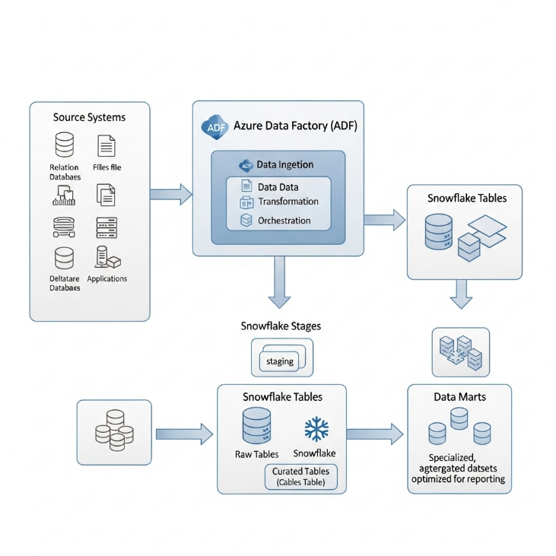

**3.3. Technology Stack**

| Component | Technology | Purpose |
| --- | --- | --- |
| **Orchestration** | Azure Data Factory V2 | Data movement and workflow orchestration |
| **Data Warehouse** | Snowflake | Scalable data storage and processing |
| **Secret Management** | Azure Key Vault | Secure credential storage |
| **Source Systems** | Azure SQL DB, Blob Storage, Cosmos DB | Enterprise data sources |
| **Monitoring** | Azure Monitor, Log Analytics | Pipeline monitoring and alerting |
| **Data Transformation** | Snowflake SQL, ADF Data Flows | Data processing and enrichment |
| **Authentication** | Azure AD, Managed Identity | Secure access management |

**4. Implementation**

**4.1. Prerequisites and Environment Setup**

**Azure Infrastructure:**

* Azure Data Factory instance with Git integration enabled
* Azure Key Vault for secrets management
* Azure Storage Account for temporary data processing
* Network security groups and private endpoints configured

**Snowflake Configuration:**

* Snowflake account with appropriate roles and privileges
* Databases and schemas for raw, transformed, and mart layers
* Virtual warehouses for different workload patterns
* Security integration with Azure AD

**4.2. Core ADF Pipeline Implementation**

**Step 1: Create Linked Services and Connections**

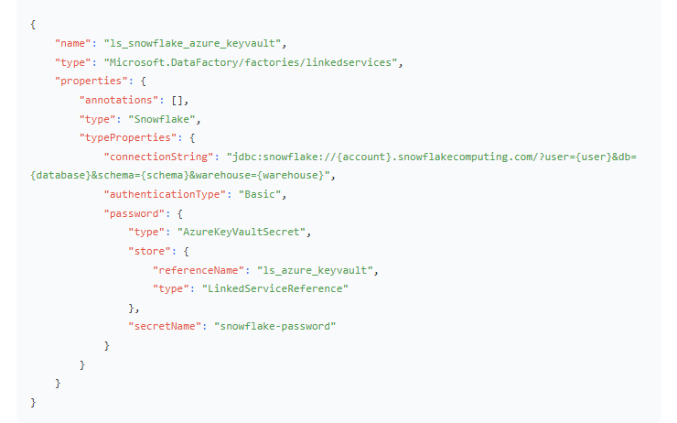**Step 2: Implement Metadata-Driven Pipeline Framework**

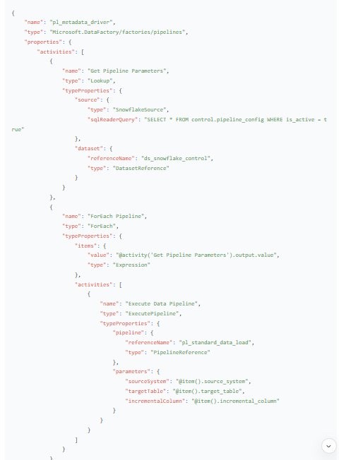

**Step 3: Implement Incremental Load Pattern**

json

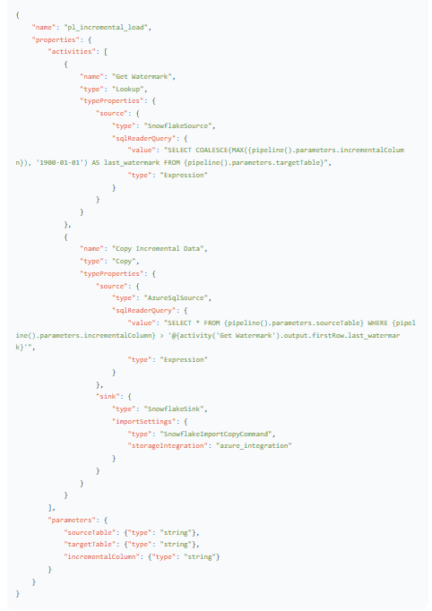

**4.3. Data Transformation Implementation**

**Step 4: Create Snowflake Stored Procedures for Transformation**

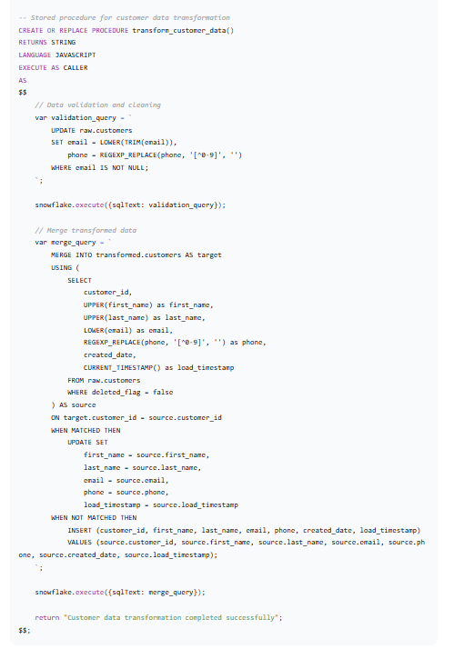

**4.4. Monitoring and Error Handling**

**Step 6: Implement Comprehensive Logging**

sql

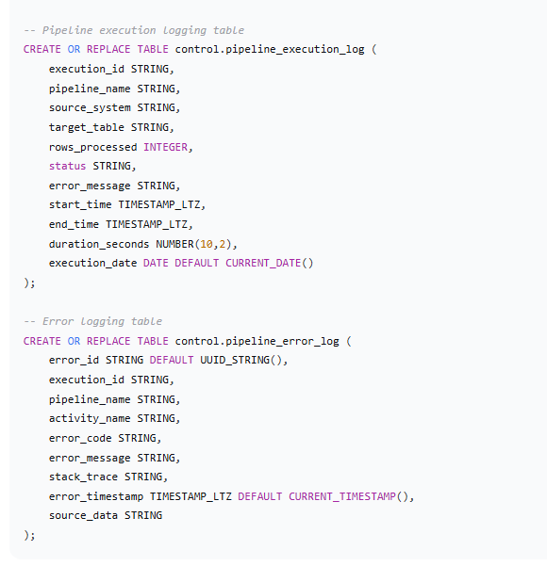

**5. Results and Validation**

**5.1. Performance Metrics**

The ADF-Snowflake integration demonstrated exceptional performance:

* **Data Volume:** Successfully processed 15+ TB of data monthly across 50+ data pipelines
* **Processing Speed:** Reduced ETL processing time by 65% compared to previous SSIS-based solution
* **Pipeline Reliability:** Achieved 99.5% pipeline success rate with automated retry mechanisms
* **Data Freshness:** Improved data latency from 24 hours to near real-time (15-30 minutes)